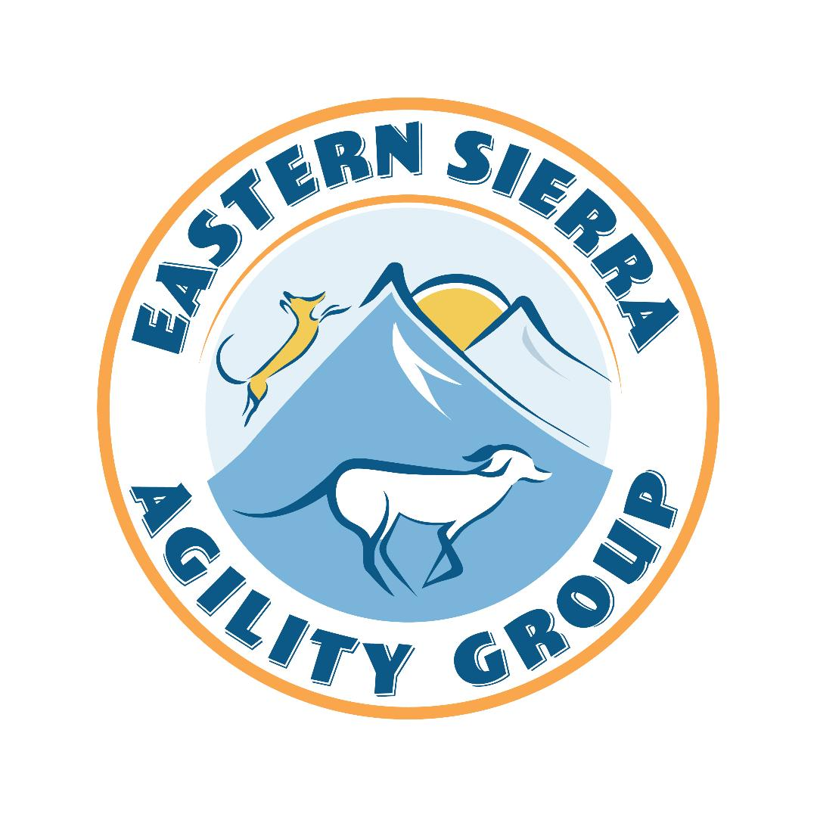
High Sierra Agility Challenge  August 18-20, 2023  Whitmore Sports Complex, 575 Benton Crossing Rd., Mammoth Lakes, CA  Judges:  Marj Vincent & Jeannie Biggers,  Ontario, OR  Trial Format: Double Run  Building and Ring Surface info:  Outdoors on grass; 2 rings set and run (mostly) alternately; entire field fenced; rings enclosed with net fencing. Entry/exit gating available upon request.  Contact Surface, Equipment: Rubber Matting; all equipment conforms to NADAC specifications.  Crating Set up times: Fri, Sat & Sun: 7 a.m. Limited access Thursday afternoon/evening as field will be watered Thursday night.  Briefing: Friday 9am; Sat & Sun 8am, briefing notes will be available online.  First dog on the line: Friday 9:30am; Sat & Sun 8:30am.  General questions: Lynne Almeida, lynne_spellbinder@verizon.net; or text 760.920.2295  Entry questions: Alix Ginter, alixginter@aol.com | Preliminary Class Order:  May change depending on weather, judge’s preference, time, or number of entries.  Friday  Class: Double Run Single Run  Regular 2  Weavers 2  Chances 2  Saturday  Class: Double Run Single Run  Regular 2  Jumpers 2  Touch n Go 2  Grounders 2  Sunday  Class: Double Run Single Run  Regular 2  Chances 2  Tunnelers 2  Visit our web site for results, course maps and other trial info.:  www.esaginc.org

Entries Open: now  Entries Close: 8/16/23 at 6pm  ONLINE ENTRIES NOW AVAILABLE! LINK IS ON our web site.  If you are entering online, your entry will not be considered complete until both your entry form and your payment have been received.  Entries will be processed in the order in which they are received.  Confirmations:  Via email  Crating available: ringside; bring shade; make sure to stake and guy-line your shade structure thoroughly and correctly due to possible wind!  Entry Limits: Limited to 500 runs per day - 350 with Jumps  Move ups: Pre-trial move-ups will be accepted until 6 PM, August 16 by e-mail or phone call to the trial secretary. Move-ups will also be allowed from Friday to Saturday and Saturday to Sunday during the trial. No same-day move-ups.  Day of show Entries: available if space allows at $15 per run  Refunds: See “Brief Summary of Rules” and “ESAG, Inc. Policies” sections.  If the trial needs to be cancelled due to severe smoke from wildfires, refunds will be given.  Results: Results, along with course maps and other trial info., will be posted electronically. Your results summary will be emailed to you after the event. | Show Committee:  Chair – Lynne Almeida  Secretary – Alix Ginter  Scorekeeper, Awards – Raven Angeles  Course Builder – Bobbie Eddy  Ring Crew – Nik Barbieri, Matt Ulery  Hospitality – Pam Barker, Debbe Eilts  Ring Steward – Monica Nolan, Katie Smith  Equipment Coordinator – Johnny Williams  Food info:  We will be supplying water, coffee, and snacks throughout the day, and are arranging for a lunch delivery or on-site food truck each day. Please bring everything else you and your dogs might need for sustenance.  Volunteer info:  Any trial relies on volunteers to run well and efficiently! Tickets earned can be ‘spent’ on our cash raffle and maybe a few new surprises!  Note that while we will be seeking leash runners, you do have the option of carrying your leash. Hand sanitizer will be readily available for all participants.  Awards and Ribbons:  Q ribbons, and ribbons for 1st through 4th place in each class, will be available.  Please let us know in advance if you may earn a NATCH of any kind at our trial so we can celebrate together! We have lovely rosette ribbons for you. We are now giving a standard-length pole for your first NATCH. Subsequent NATCHES of all kinds receive a short pole.
Jump Height Info:
MEASURING
Measurement forms may be obtained at: https://www.nadac.com/WPsite/wp-content/uploads/2021/06/Permanent-Height-Card-form-6.4.21.pdf
Dogs which require measuring:
Dogs in the Proficient Category, Novice, Open or Elite jumping 4”, 8”, 12” or 16”

Dogs which do not need to be measured:
Dogs jumping 16” in the Veteran or Junior Handler Division
Dogs jumping 20”
Dogs in the Skilled Category
Dogs with a permanent height card
Dogs listed on the Height Exemption List
JUMP HEIGHTS
There are four Standard Division-Proficient jump heights: 8”, 12”, 16”, and 20”.
There are four Standard Division-Skilled jump heights: 4”, 8”, 12”, and 16”.
There are four jump heights for the Veterans and Junior Handler divisions: 4”, 8”, 12”, and 16”.
Please see the NADAC Rulebook for the full jump height table

Brief Summary of Rules:
Please refer to www.nadac.com for a full explanation of all NADAC rules and up to date information.

- Please note that NADAC trials should provide a safe and fun environment for both exhibitors and their dogs.
- Aggressive dogs will not be tolerated and will be excused from the trial.
- The show committee has the right to refuse any entry. Anyone not currently in good standing with NADAC will not be allowed to enter this trial.
- Exhibitors, through submission of entry, acknowledge that they are knowledgeable of NADAC rules and regulations, and agree to abide by all rules in effect at the time of this trial.
- No entry fee will be refunded if the trial cannot open or be completed by reasons of riots, civil disturbances, fire, acts of God, public emergency, an act of a public enemy, or any other cause beyond the control of the organizing committee.
- Checks not honored by the bank do not constitute a valid entry fee. There will be a $25.00 service charge for bank returned checks.
- Dog must be registered and have a valid registration number before entries will be accepted. https://www.nadac.com/register-your-dog/
- A copy of the current Exhibitors Handbook may be downloaded free from the NADAC web site: www.nadac.com
- Bitches in heat, lame, or blind dogs are ineligible for entry, as is any dog with a deformity which may cause a judge to not be able to reasonably assess the dog’s ability to function and perform agility obstacles safely, and in a manner that is in the best interest, health and welfare of the dog.
- No food, clickers, or other aids or devices shall be permitted on the course or within 10 feet of the ring. Food or a small non-audible toy can be in a secure container (ziplock bag is acceptable) in your pocket during your run but you cannot indicate to the dog it is there. All handlers may bring a non-audible toy into the ring for training purposes. They cannot earn a Qualifying score and must declare to the judge they are training before they commence their run. Please read the Exhibitor’s Handbook for more information about toys and training in the ring.
- The sponsoring clubs will not be responsible for the loss or damage to any dog exhibited, or for the possessions of any exhibitor whether the result be accident or other cause. It is distinctly understood that every dog at this event is in the care and control of his owner or handler during the entire time the dog is on the show premises.

ESAG Inc. High Sierra Agility Challenge, August 18-20, 2023, Mammoth Lakes CA
Make Checks Payable to: ESAG Inc. Send to: Alix Ginter, PO Box 7044, Mammoth Lakes CA, 93546
Owner |  |  |  |  | Dog
Name |  |  |  |  | Call Name
Address |  |  |  |  | NADAC Reg #
City/State/Zip |  |  |  |  | Date of Birth
Phone |  |  |  |  | Height at Withers
Email |  |  |  |  | Breed
Handler, If not owner |  |  |  |  | Emergency Contact Name/Phone
PLEASE INCLUDE A COPY OF YOUR DOG’S HEIGHT CARD IF YOU DO NOT HAVE ONE ON FILE.
CATEGORY: PROFICIENT SKILLED
DIVISION: STANDARD VET DOG VET HANDLER JUNIOR HANDLER
I WANT MY DOG TO JUMP: 4 8 12 16 20
Class | Level |  |  |  | Day
 | Intro | Novice | Open | Elite | Friday | Saturday | Sunday
Regular |  |  |  |  | Rd 1 Rd 2 | Rd 1 Rd 2 | Rd 1 Rd 2
Chances |  |  |  |  | Rd 1 Rd 2 |  | Rd 1 Rd 2
Jumpers |  |  |  |  |  | Rd 1 Rd 2
Touch n Go |  |  |  |  |  | Rd 1 Rd 2
Tunnelers |  |  |  |  |  |  | Rd 1 Rd 2
Weavers |  |  |  |  | Rd 1 Rd 2
Grounders |  |  |  |  |  | Rd 1 Rd 2
In consideration of the acceptance of this entry, I/we certify that I/we have knowledge of, and are familiar with, and agree to abide by, the Rules and Regulations of NADAC in effect at the time of this trial, and by any additional rules and regulations as approved by NADAC for this trial. I/we certify that the dog entered is not a hazard to persons or other dogs. I/we further agree to be bound by the “Agreement” printed on page 5 of this premium

Run Pricing is Total per Household
1- 8 Runs = $14 each x ______= ___________ Junior Handler = $5 each = ___________
9-19 Runs = $13 each x _______= ___________ Day of Show (after closing date) $15 each = ___________
20-29 Runs = $12 each x _______=___________
30+ Runs = $11 each x ________=____________

Total # of Runs Entered (all dogs): # ___________ TOTAL ENCLOSED =___________

Owner/Exhibitor: ____________________________________Date______________________
Parent or Legal Guardian of Junior Handler__________________________________________

AGREEMENT
The person who signs this agreement represents that he/she is authorized to enter into this agreement on
behalf of both exhibitor and the owner of entered dog. In consideration of acceptance of this entry:
1.1. As used here "NADAC" means the North American Dog Agility Council, LLC., its members, officers, directors, employees, show chairs, show committees and agents.
1.2. Exhibitor/owner agree to abide by the rules and regulations of NADAC and any other rules and
regulations appearing in the premium for this event.
1.3. Exhibitor/owner certify that the entered dog is not a hazard to persons, dogs or property and that
the entered dog's rabies vaccination is current in accordance with the requirement of the state in which the dog resides.
1.4. Exhibitor/owner acknowledge all hazards presented by the event and the event premises,
including, but not limited to, the condition of the surface, restrooms, security measures or lack of,
electrical appliances, fittings, show rings, parking areas and the presence of unfamiliar animals and
people; exhibitor and owner assume the risk of any harm arising from these.
1.5. Exhibitor/owner releases NADAC (including its respective officers, directors, employees, and
members), ESAG Inc. (including its officers, directors, members, and event organizing
committee), and the Town of Mammoth Lakes (including its officers, agents, and employees) and will
defend them and hold them harmless from all present and future loss, injury, damage, claims, demands
and liabilities involving the entered dog, the event or event premises. Without limiting the generality of the
foregoing, hold harmless provisions, exhibitor/owner hereby specifically assumes sole responsibility for
and agrees to indemnify and save the aforementioned parties harmless from any and all loss and
expenses (including legal fees) by reason of the liability imposed by law upon any of the aforementioned
parties for damages because of bodily injuries, including death, at any time in consequence of my (our)
participation in this event, howsoever such injury or death may be caused and whether or not the same
may have been caused or may have been alleged to have been caused by negligence of the
aforementioned parties or any of their employees or agents or any other persons

ESAG POLICIES
THIS YEAR: IF OUR TRIAL IS ANNOUNCED AND THEN IS UNABLE TO BE HELD DUE TO COVID-19 RESTRICTIONS, REFUNDS WILL BE ISSUED. EVERY YEAR: WILDFIRE SMOKE IS NOW A POTENTIAL REALITY. IF WE HAVE SMOKY SKIES EXCEEDING AQI 150 IN THE MORNING, PARTICIPANTS WILL BE GIVEN THE OPTION TO WITHDRAW FROM CLASSES FOR A REFUND ON A DAY-TO-DAY BASIS. IF AIR QUALITY REACHES A HIGHLY HAZARDOUS LEVEL, CLASSES MAY BE CANCELLED AT THE JUDGMENT OF THE TRIAL COMMITTEE.
- These polices are in addition to the NADAC rule summary to be found on page 3 of this premium.
- ESAG reserves the right to refuse any entry.
- Only handlers who are officially entered in the trial and have submitted an application with the handler’s signature accepting “Agreement”, NADAC Rules, and ESAG Policies, and with payment in full, will be allowed to run dogs in the trial.
- All dogs must be on leash, or contained securely in a crate or ex-pen, when in the trial area and not competing in the ring.
- Please abide by rules of good sportsmanship and stewardship and clean up after yourself and your dog.
- Safety shall be the foremost consideration in actions and conduct by handlers at all times.
- There will be no refunds for entries withdrawn after the closing date, or in the event a dog and/or handler is dismissed from competition, regardless of the reason for such dismissal.
- Refunds will be issued for bitches in season if submitted in writing BEFORE the trial date, with a statement from your veterinarian.
- No setups within 15 feet of the ring, please.

Lodging Info and Directions:
HOTELS/MOTELS THAT ACCEPT DOGS

Town of Mammoth Lakes (10-15 minutes from field)
Motel 6—3372 Main St. . . . (760) 934-6660
Travel Lodge—54 Sierra Blvd. . . . (760) 934-8892
Shilo Inn—2963 Main St. . . . (760) 934-4500
Mammoth Reservations (condo rental) - (800) 223-3032

Crowley Lake (5-7 minutes from field)
Convict Lake Resort—Convict Lake Rd. . . . (760) 934-3800
McGee Creek Lodge – Crowley Lake Drive . . . .http://mcgeecreek.com/

RV PARKING & CAMPING
We are very sorry, Town of Mammoth Lakes’ current lease agreement with LADWP does not allow overnight camping at the Whitmore facility. We understand this is disappointing for many but is entirely beyond our control.

OTHER RV/CAMPING FACILITIES

Mammoth Mountain RV Park, full service RV park at the edge of Town of Mammoth Lakes, https://www.mammothrv.com/
McGee Creek RV Park and Campground, full hookups and shade trees, less than 10 minutes’ drive from Whitmore; info@mcgeecreekrvpark-campground.com
Brown’s Campground, scenic dry camping a few minutes east of Whitmore with fishing access https://brownscampgrounds.com/owens-river-campground-2/
Crowley Lake Fish Camp, at the Marina at the opposite end of Long Valley. Some full hookup sites, some dry. https://www.crowleylakefishcamp.com/camping

Crowley Lake RV Park, in the community of Crowley Lake at the opposite end of Long Valley, about 10 minutes from Whitmore. Full service RV Park: http://www.crowleylakerv.com/
Crowley Lake BLM Campground, less than 10 minutes from Whitmore. Very basic dry camping, only $8 a night, but no reservations – first come, first served. https://www.blm.gov/visit/crowley-lake-campground-0

DIRECTIONS TO WHITMORE BALL FIELD/SPORTS COMPLEX

From Reno: Take US 395 South towards Mammoth Lakes, CA. Continue past the exit to Mammoth (CA-203) for approximately 4 miles to Benton Crossing Rd. Turn left at the Green Church on Benton Crossing Rd. Whitmore Ball Field is 3/4 mile on the left. Take the very first left after the dog shelter and continue through the back of the parking lot; our field is the western-most one in the back.

From Los Angeles Area: Take US 395 North past Crowley Lake, CA. Turn right at the Green Church on Benton Crossing Rd. Whitmore Ball Field is 3/4 mile on the left. Take the very first left after the dog shelter and continue through the back of the parking lot; our field is the western-most one in the back.

BOTH LOCAL VETS OFFER EMERGENCY SERVICES (24 Hour)
Mtn View Animal Hospital Bishop Veterinary Hospital
174 S Main St. 1650 N Sierra Highway (US 395)
Bishop, CA Bishop, CA
(760)873-3500 (760) 873-5801

Blue-Green Algae - Find the latest reports and information at: https://mywaterquality.ca.gov/habs/where/freshwater_events.html

